**\*The new user guide can be found here:\***

<https://peopoly.dozuki.com/Guide/Step+0+-+Start+Guide/1>

Steps:

**1. Putting the Moai hardware together**

The best guide for putting the kit together is to follow the guide [here](https://drive.google.com/open?id=0Bzke6lBHG_z5Uk1RTWE0eVNfRUU):

We recommend not finish the final step of putting on righ Panel and move to calibration. Only close the panel after calibration is done.

Content Checklist: [Here](https://drive.google.com/open?id=1B0uXz7hV-ck8P0Gu3KoERtkeMGY4Axt0wk5epfuWcyI)

Helpful files:

Or watch the movie step [here](https://www.youtube.com/watch?v=0IkJAOsbeYE)

The layout pics are [here](https://drive.google.com/open?id=0Bzke6lBHG_z5cVQyWGp2cWZzTzQ):

The screws are grouped into bags and you can reference the labels on the beams to the photos

**2. Check**

After putting the kit together, (but before putting the side panels on, it is best to do a check.

Please refer to [this document](https://drive.google.com/open?id=1R4ggLXtaHLgEfPj2fK2P_7y7HjT0qA91M-NNgyH7Ak4) for the check steps.

**3. Software Installation**

After calibration, it is time to set up software.

The instructions is here:

Before you can print, you would need to install:

Cura 2.6 from [here](https://drive.google.com/open?id=0Bzke6lBHG_z5cjJPNHdXaFZrWWM)

Cura 2.6 profile: [here](https://drive.google.com/open?id=0Bzke6lBHG_z5cjJPNHdXaFZrWWM)

Meshmixer

You do not need to install any hardware driver

-

For cura 2.6

During installation, no need to install Arduino driver:

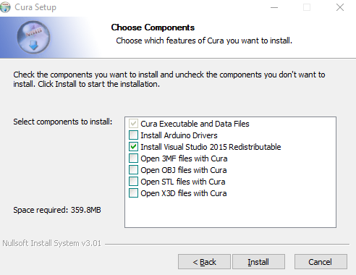

After the program is installed. Run Cura Moai Edition.

And it will ask you to add a printer.

Please add Peopoly Moai under Other

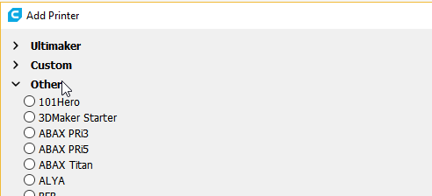

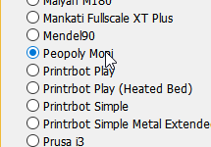

This will give you correct printer setting

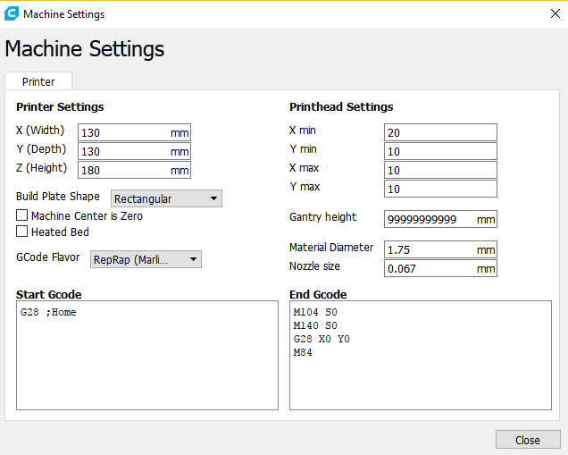

Next, go to settings -> Profile -> Manage Profiles

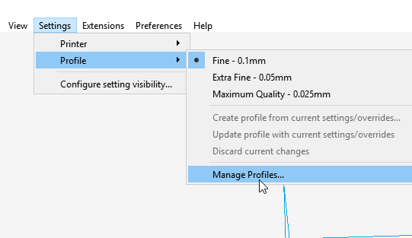

Download the profiles from our Google Drive [here](https://drive.google.com/open?id=0Bzke6lBHG_z5VG9hTV9KallOTjA)

Extract the files and you will see:

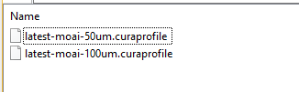

Go back to Cura and Click Import

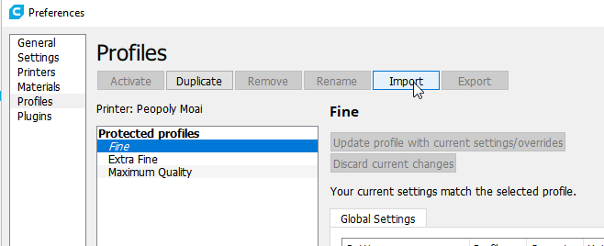

Import both profiles from files extracted from the downloaded zip file. And you will see:

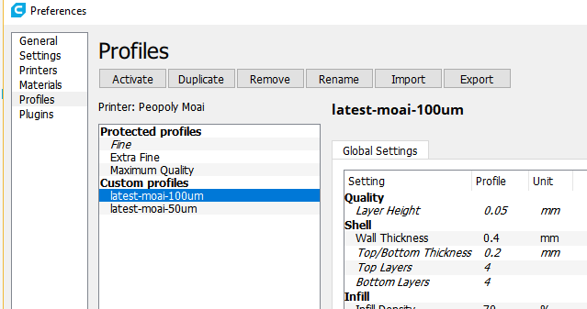

Make sure all the settings are visible by going into:

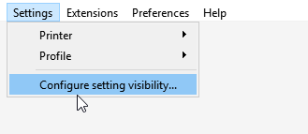

Select “Check all”

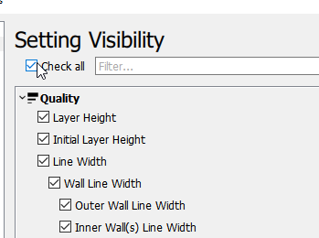

Now select the newly Imported profile

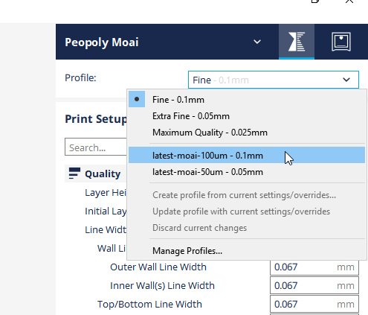

You are ready to print at layer height 0.1mm

Please select custom for print setup to open up more settings

**Quickly check the nozzle size is 0.067mm by looking at line width**

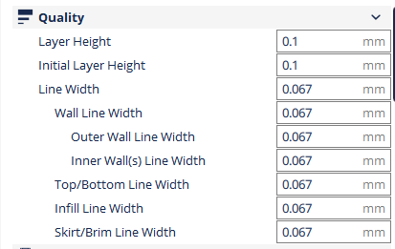

And print speed is 85mm/s with first layer 5mm/s for 0.1mm layer height at 61% laser power

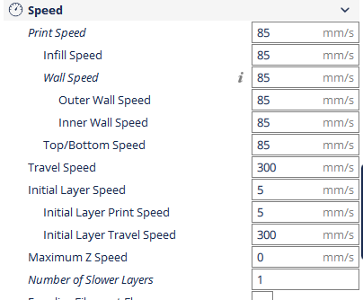

**Ensure Support is off and Build Plate Adhesion is set to None**

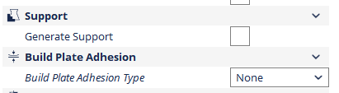

**4. Dry test (without resin)**

Resin can get messy so let’s check functions before we start printing.

You can test print the Moai stl file [here](https://drive.google.com/open?id=0Bzke6lBHG_z5NEFJYzdoVlZIU3M) using the settings.

* Load the stl file into Cura
* Move it to C spot indicated below on Cura platform

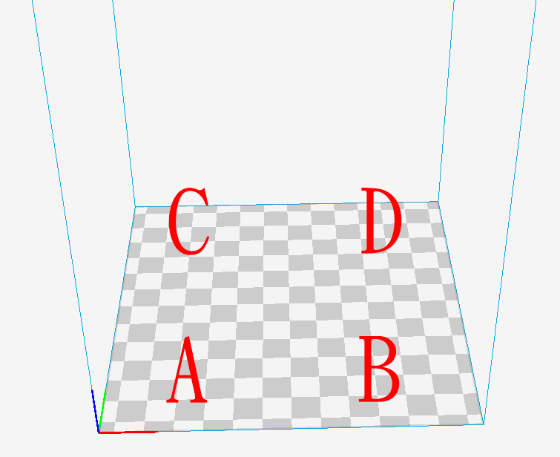

Like this

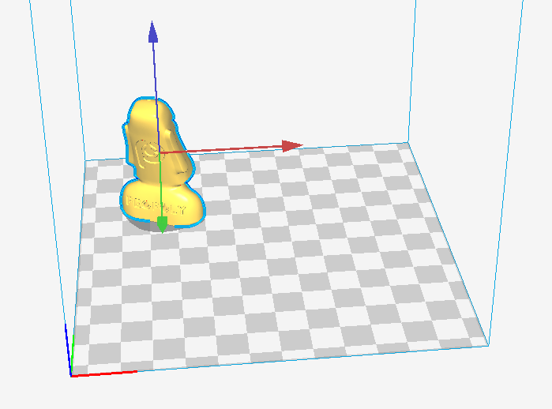

* Use Cura to slice the file,

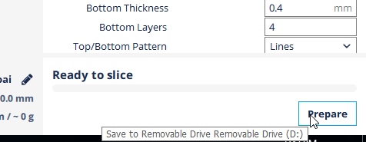

* save to SD card’s gcode directory and
* Put the SD to the printer and print from menu

As it goes to each layer,

Check the peel action at each layer and see if Z-axis is moving correctly. It should steadily move upward.

--

This is Cura’s platform:

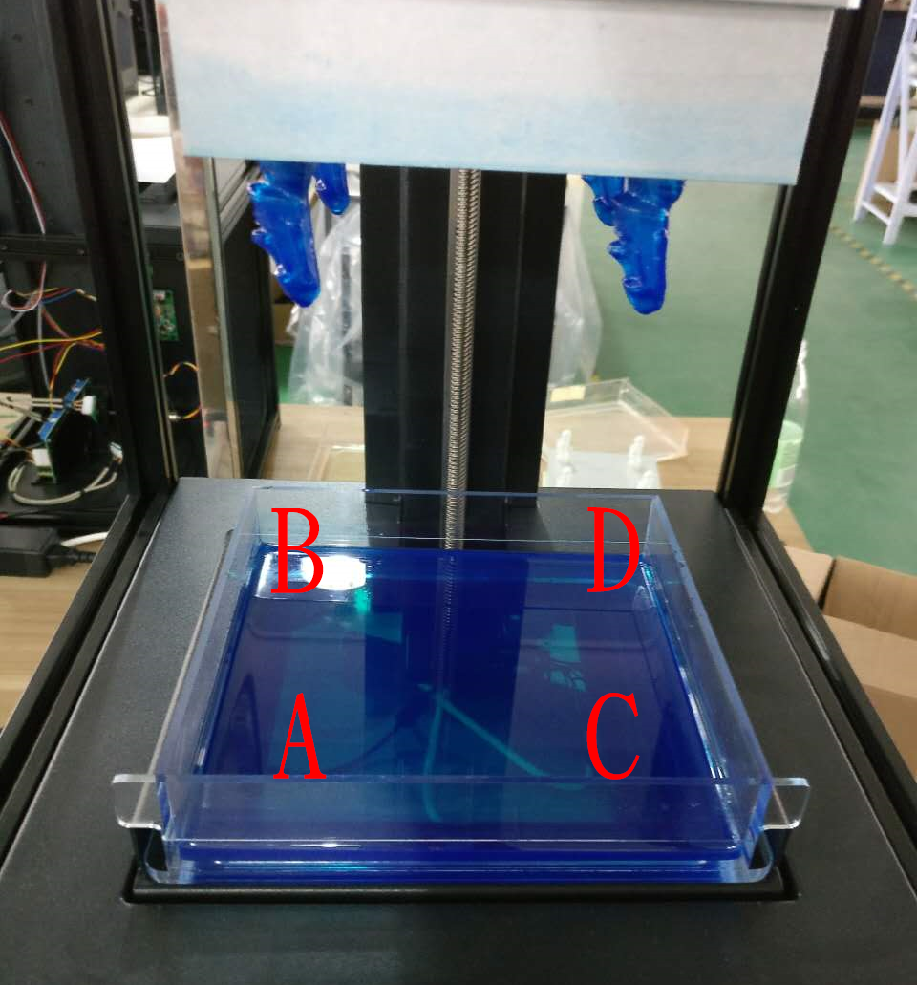

Action sequences should be:

Laser scan the toolpath -> peel action (the VAT is tilted) -> platform moved upward

First layer will be slow because just like FDM, we want good adhesion to platform and we use much longer exposure time to make sure that sticks well. (you can see that in cura settings)

If it goes smoothly with no loud noise or sudden stoppage, we can move to full printing. If something is going wrong, hit the power button and it will reset.

**5. Printing instruction**

Full printing guide is [here](https://drive.google.com/open?id=1wZhVToWbOOYvWisfJB7dk12SeblLANutIcp-jKCTicw)

5.1 Leveling [instruction](https://drive.google.com/open?id=1MeXCjGVIVvCN8XrciehLLfmdflCe3DazT6CqE1-7oew)

**5. Resin handling! Very important**

The above setting is only for the resin we send you. UV Resin from other brands can work but will have different settings. Here are some of the things you need to know about handling resin.

Most UV Resin has very low toxicity. However, it is never good idea to touch it with bare skin and definitely not a good idea to contact eyes or to ingest. If that happens, wash with warm water. If you get some on your hand, it may cause some itchiness. It is very recommended you wear disposable gloves.

Here are some good info from Formlabs:<https://formlabs.com/support/materials/resin-care/>

https://formlabs.com/support/printers/form-1/safety-first/

Before you pour resin into the vat, make sure you shake the resin bottle well. Do not pour more than half of the vat unless you are printing something big. For testing, fill one-fifth of the tank is more than enough. When you pour, there will be bubbles in the resin, let it sit for awhile before you start printing. Some resin is sensitive to temperature. It is best to print between 20 - 30 celcius.

Once you start the printing process, wait for the layers to build up and observe for formation of layers. It usually takes at least 30 layers to be easily visible. If you hear a suction sound, it means resin is sticking well to both vat and the platform. If suction is super loud and continues after 30 layers, you may consider stop printing to make sure it is not sticking too well. Resin curing too well may damage vat too quickly. This is something quite unique to SLA printing process.

A very critical part of the printing process is that:

NEVER REMOVE VAT when the build platform is still on the printer. This is because there may be resin stick on the platform and may drip down into the printer laser/galvo if you remove the vat first. This is very critical!

Post processing:

Another unique aspect of resin printing is post-processing. You can use 99% alcohol to wash off uncured resin sticking on the object. It is best to keep 2 containers, one with alcohol and one with water. Dip and quickly shake the model in alcohol and wash for 30 sec before moving to water to clean some of the mixture off, then move the model back into the alcohol and clean some more again. Do Not Leave the Model in the alcohol. It will damage the cured resin if leave in too long.

Here are some good instruction from Formlabs: <https://formlabs.com/support/finishing/post-print-steps/>

Cleaning:

It is best to use paper towels to clean resin. Never use a piece of cloth. Just throw away.

You can also use alcohol to clean resin off table and other surfaces but do not get alcohol into the vat to mix in with resin. You can use alcohol to clean back of the vat.

Tools you will need:

2 containers, one for water and one for alcohol.

1 metal scraper just like the one used for FDM printer.

1 plastic scraper for cleaning the bottom of the vat as metal may damage it

99% alcohol for cleaning resin off. Anything above 90% would do

Paper towels

Flat head Picker for grabbing onto the printed object

Safety information is also presented in the [print guide.](https://drive.google.com/open?id=1wZhVToWbOOYvWisfJB7dk12SeblLANutIcp-jKCTicw)